Yogesh Sharma

***ADDRESS:***

***WZ 420 Madipur village, New Delhi***

***110063***

***Email:*** [***yogeshsharma0899@gmail.com***](mailto:yogeshsharma0899@gmail.com)

***CONTACT: (91) 9999378766***

***(91) 9999558207***

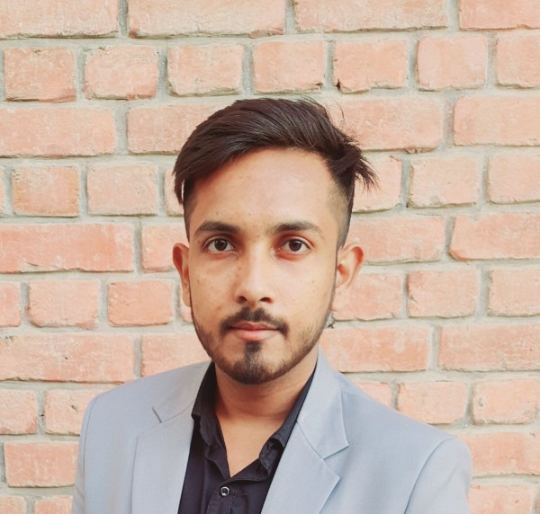

***OBJECTIVE***

My purpose behind joining the sports industry is to be able to change the Indian mindset & culture which currently emphasizes on achieving good education and jobs, to emphasizing on bringing out the athletic and sharp talent within the country. I would like to encourage the youth of India to take up sports as a career and be able to contribute more towards making India stand among the best performing countries in the Olympics. Further with India's growing Sports Infrastructure I would like to enhance and improvise certain aspects of the Sports & improve the spectator's experience all over India.

|  |  |  |  |  |  |
| --- | --- | --- | --- | --- | --- |
| *EDUCATIONAL QUALIFICATION* | | | | | |
| *Qualification* | | *Course* | *University/school* | | *Year* |
| *Graduate (Teacher training course)* | | *B.P.Ed*  *(Bachelor in Physical education)* | *Amity University* | | *2021-23* |
| *Graduate* | | *B.P.ES*  *(Bachelor in physical education and sports)* | *Amity University* | | *2018-21* |
| *Senior School* | *Secondary* | *12th* | *S.M Arya School* | *Public* | *2017-18* |
| *Secondary School* | | *10th* | *S.M Arya School* | *Public* | *2015-16* |

|  |  |  |
| --- | --- | --- |
| *Professional Experience* | | |
| *Organization* | *Peroid* | *Role And Responsibilities* |
| *Kendriya vidyalaya samiti* | *38 days* | *Intern coach and Integration to curriculum.* |
| *Youth unity sports club* | *40 days (2020)* | *Yoga coach* |
| *Youth unity sports club* | *40 days (2021)* | *Yoga coach* |

|  |  |  |  |
| --- | --- | --- | --- |
| ***Volunteer*** | | | |
| *Tournament Name* | *Position* | *Roles and Responsibilities* |  |
| *Special Olympics Bharat* | *Volunteer* | *Conducted recreational activities for Special children.* |  |
| *Amity Futsal Tournament* | *Volunteer* | *Refer ship in the tournament* |  |
| *Self Defence workshop for women.* | *Volunteer* | *Organized various self defence activities.* |  |
| *Amity Sangthan (2018,*  *2022)* | *Volunteer* | *Officiating in football and volleyball.* |  |

1. *2nd Position in district volleyball tournament.*

***Awards And Accreditation***

1. *3rd position In zonal level football tournament.*
2. *Participated in Amity football leaugue.*

***Personal Information***

***Interpersonal Skills:*** *Teamwork, Leadership, Innovative,*

*Enthusiastic.*

***Hobbies:*** *Sports, Fitness, Sports Coaching, Cricket, Football, Volleyball, Water Sports, Politics, Music, Sightseeing And Travel.*

*Proficient at* ***Microsoft office And PowerPoint.***

*I hereby confirm that all the details provided above are true to my understanding.*

*YOGESH*

*SHARMA*